**1. Display the date using ‘date’ command.**

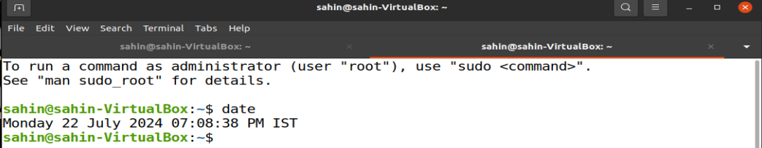

**2. Check who are the users logged in using the ‘who’ command.**

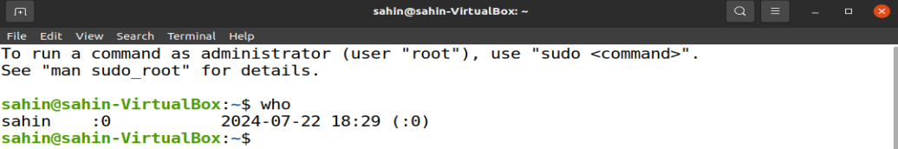

**3. Check the running processes using the ‘ps’ command.**

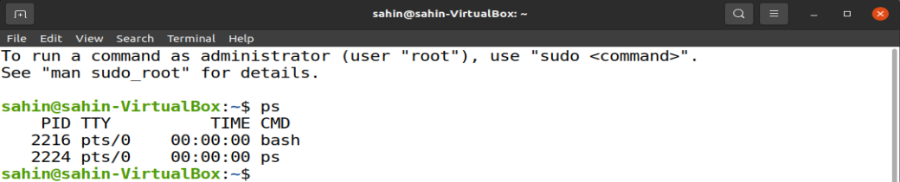

**4. List the files with ‘ls’ command with and without –l option.**

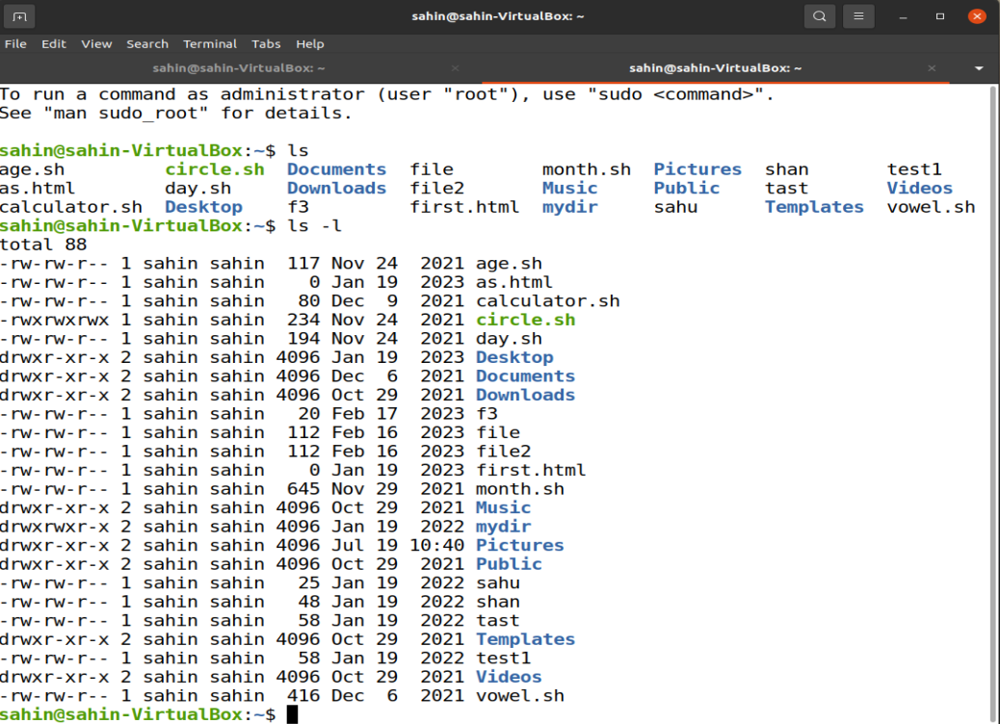

**5. Check the manual of ‘ls’ command.**

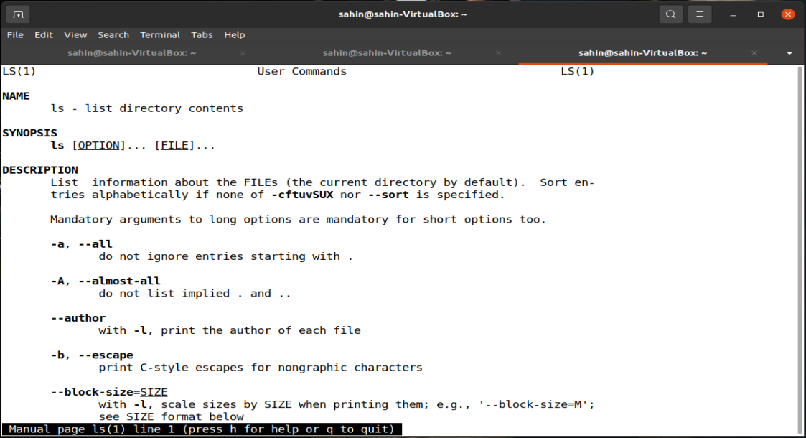

**6. Show the command used to display (i) filenames (ii) processes (iii) users.**







**7. Check and state the difference between man and whats command by checking man cp & whatis cp**

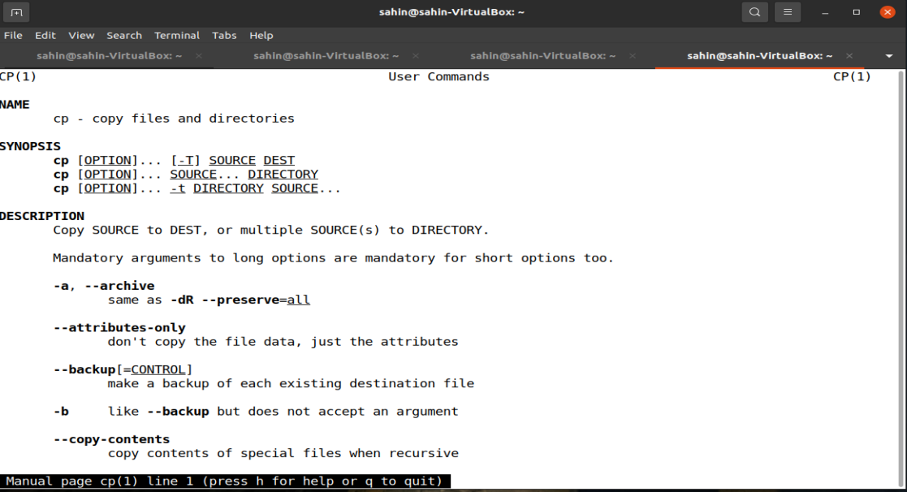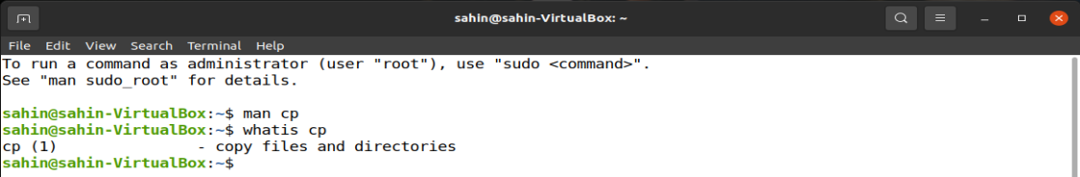

**8. What is primary difference between printf and echo command. Check and print.**

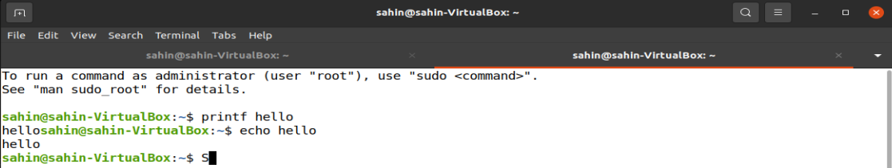

**9. In the home directory, create a directory MCA2022 inside the MCA2022, create another directory <FirstName_Section_ClassRoll> and get into the directory [-/MCA2022/Ankur_A_00$].**

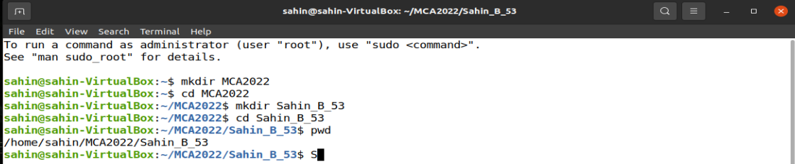

**10. Go to the subdirectory and create another subdirectory ‘Unix_File_System’ within it.**

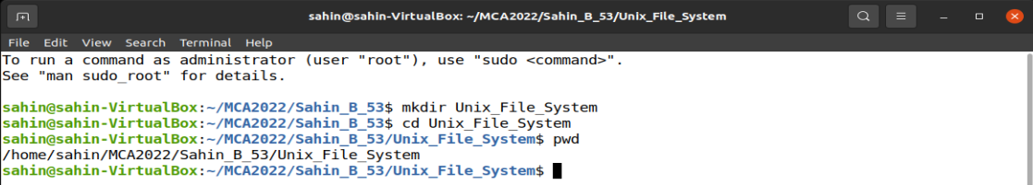

**11. Create the subdirectories TestA,TestB,TestC and corresponding sub-directories TestA-1,TestA-2, TestB-1,TestB-2, TestC-1,TestB-2-i in a single command.**

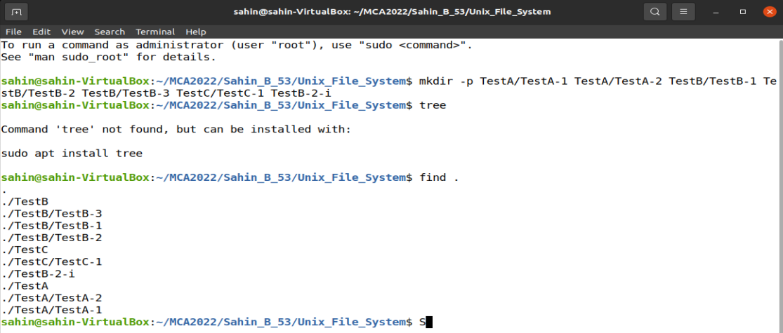

**12. Show the absolute path of TestB-2-i.**

